DNA Solutions to Searching for the Hamiltonian Cycle and the Traveling-Salesman Cycle
Shaw-Jye Wu, Yuan-Jye J. Wu, and Joe J. Shaw
Journal of Alabama Academy of Science, Vol.68, NO.3, P259-271, July 1997.
The Hamiltonian Cycle
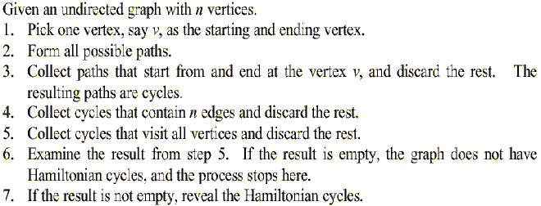

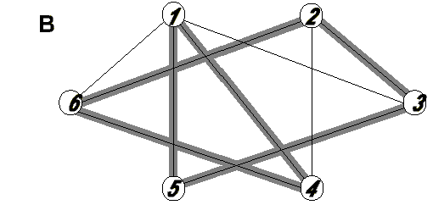
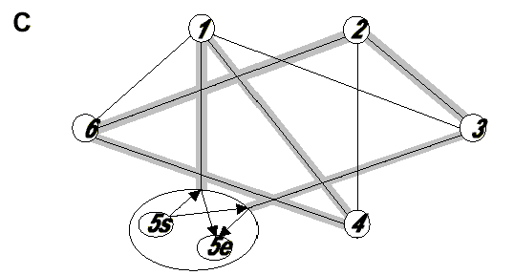

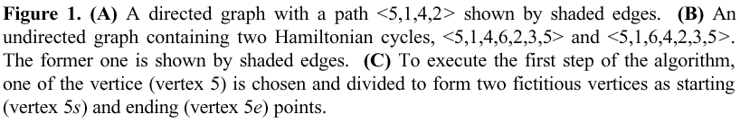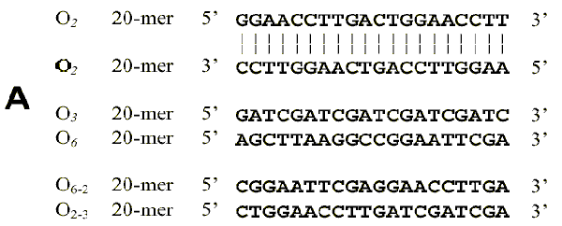

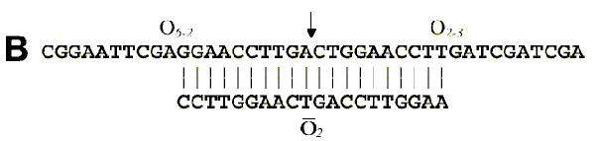

The Traveling-Salesman Problem
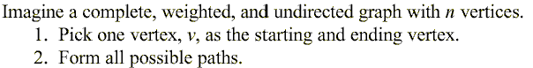
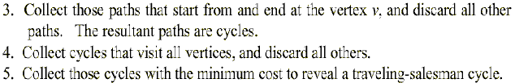
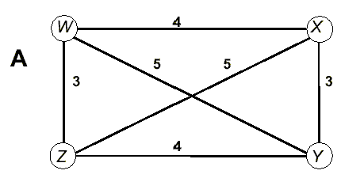
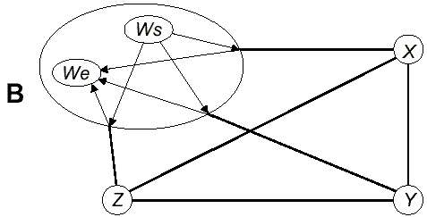

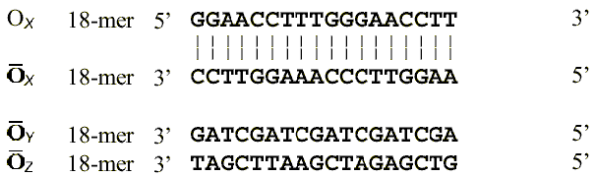

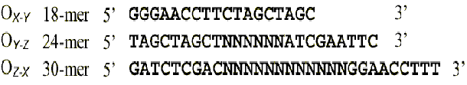
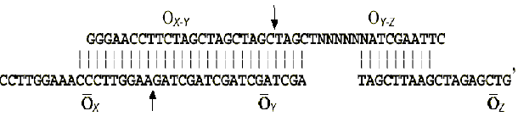

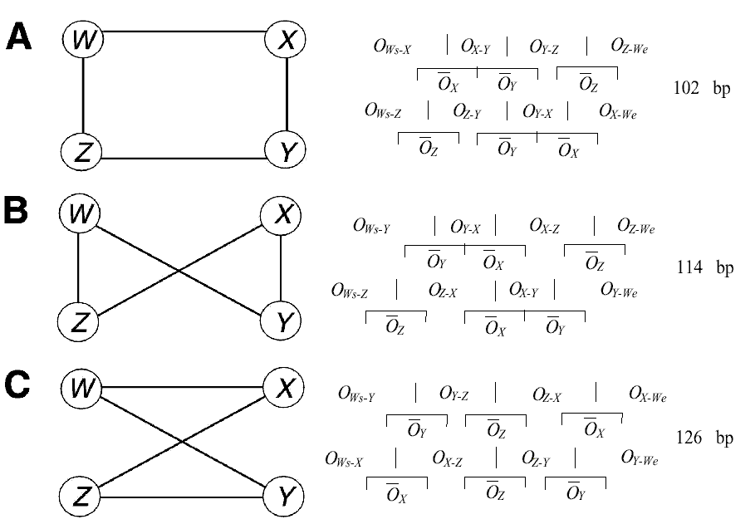

Created by : Chie-Yao hsu
Date : Oct. 15, 2002

